Forest Methodist Church

October Newsletter

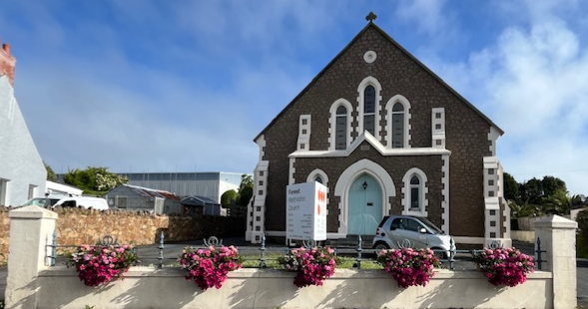

Serve Learn Share Praise
Methodist Church 
Bailiwick of Guernsey
Minister:
Rev’d Jacky Cottrell
The Manse, 2, Le Chene D’Mont, Le Chene,
Forest, GY8 0AL Tel: 234105
Email: revdcottrell@gmail.co
Dear Friends,
I recently went on a long walk, it was something I had challenged myself to do for a while. I went from the Manse to Les Adams church. It was a lovely day and turning at Le Bourg, I decided to pop into Forest store for some food to keep me going. A currant bun was ideal! Now as I journeyed, I found many other foods to sustain me. Dark damsons plums, sweet plump grapes, and juicy little tomatoes, which I devoured most of. Next I discovered small melons to take home. As my walk continued, I also found some brambles (black berries) and sweet chestnuts. I felt like one of those foragers who search for food in the wild. Although I guess this is stretching it, because all but last two items were found in Hedge Veg boxes outside people’s gates, that I purchased.
Thinking of wild food however put me in mind of Matthew 6, how birds of the air, do not sow or reap but are fed by God. The passage is about not worrying - Therefore do not worry, saying, ‘What will we eat?’ or ‘What will we drink?’ or ‘What will we wear?’ For it is the gentiles who seek all these things, and indeed your heavenly Father knows that you need all these things. But seek first the kingdom of God and his righteousness, and all these things will be given to you as well. “So do not worry about tomorrow, for tomorrow will bring worries of its own. Today’s trouble is enough for today.” This made me reflect on worries, we all have them. However, if we go to God first, seek his goodness, how much lighter we feel. So that is what I did for the rest of my walk, pass to God all that troubled me. As well as admiring the view, that passes too quickly when travelling by car and hardly noticed when driving. So, as I neared my destination, I realised how God had sustained me, body and soul. I pray the same for you, whatever your day brings. God bless too, the Hedge Veg box folks.
Big blessings, Revd Jacky

CONGRATULATIONS
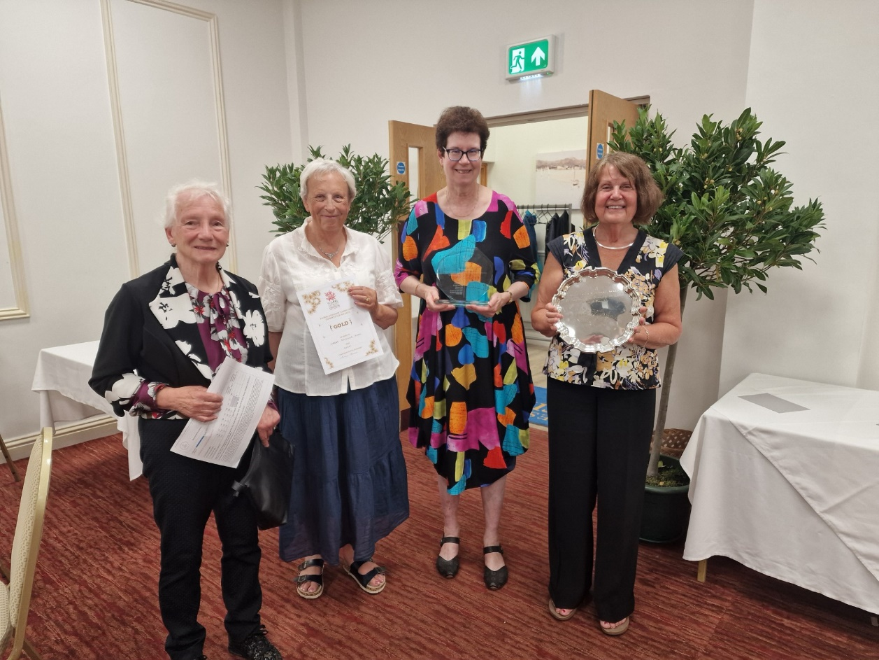
The amazing Forest Floral - they did it again; winning gold for Douzaine room and community competition, the school’s trophy. Plus, tourism trophy with theme of Liberation 80th and tour of Occupation Museum. Also, the Outstanding Contribution to Community trophy! Wow! Well done to all of them especially our very own Sarah and Jenny. What assets to our neighbourhood and how we all enjoy the colour they bring.

SOCKTOBER
For October only there will be a box in the vestibule in which to place new socks that at the end of the month will all go to homeless people. Looking after their feet is vitally important so it’s a little way we can help.

PACE EXPO
Everyone is asked not to enter our building between 9a.m. and 3p.m. during 13th-17th Oct. The reason is safeguarding, as we are hosting a special event for children to explore faith run by Pace and their volunteers. Most primary schools are involved, so exciting, literally 100’s of children crossing our threshold!
If you would like to be involved, please call Lisa or Sarah 07781 122402 to find out more.



Many thanks to everyone who helped with or supported the Harvest celebrations and the Soup Lunch.
We are pleased to have raised the following:
Harvest Lunch: £450 for famine relief in Gaza.
Soup Lunch: £458 for our next chosen charity.

MEET & EAT
This is a house group which meets usually on the first Monday of each month. We often meet at different participants homes as and when they can offer to host. There’s usually between 6 and 10 people that come along to enjoy some food followed by a discussion based on the previous Sunday’s G&M but not exclusively. We meet at 7pm and finish around 9pm. There is a minimum donation requested of £5 to cover the cost of catering.
The next Meet & Eat will be Monday 6 October at Nev and Carole’s and the final one for this year is Monday 3 November at Sarah Kelley’s home.
and will be held at Andrea’s house.
Should you wish to give us a try you can either put your name(s) on the list in the Welcome Area or call Carole on 07781 438265.

FOREST LADIES GROUP.
A very warm welcome to any lady who would
Like to join us this month when we have on
Thursday 9th October at 2.00pm
When Rod Ferbrache will be our Speaker
Thursday 16th October at 2.00pm
The Annual General Meeting led by Rev Jacky
PLEASE NOTE THE CHANGE OF DATE.
Further details from Beth Tel: 07781 163564

Conference Business Digest: A report for local churches about the business of the 2025 Methodist Conference
A copy of this can be found in the Welcome area
This can also be read online and downloaded from methodist.org.uk/conference

CIRCUIT ALPHA 2025
Still time to sign up
A warm welcome to come and join in this Alpha Course
Starting Wednesday 1st October, 6.30pm at Forest Methodist


Collection boxes
Used stamps for charity Guernsey Welfare Services
Collected and sold to raise funds for We collect non-perishable goods to be
The worldwide work of Christian Aid. Passed on to the GWS to support the
If you have any, please leave them in Work of their foodbank. Please leave any
The box in the welcome area. donations in the box in the foyer




Fairtrade stall at Forest
2nd Sunday of the month

PARKING FOR THE AIRPORT at Forest Methodist
We are letting out five spaces, on a first come, first served basis, at a cost of £20 per week or part thereof. These parking spaces will be at the back of the top rear car park and will be delineated.
THIS WILL BE ENTIRELY AT CAR OWNERS RISK
To reserve a space please email rosemary.willey@gmail.com and cc to carolejehan1972@gmail.com.
You will need to provide your car number, dates required and a contact telephone number. Please can you display your Christian name on your dashboard when leaving the vehicle.
It should be noted that on the rare occasions when the car park is full, I.e. funerals, access to your vehicle may be temporarily delayed.
THERE IS TO BE NO UNAUTHORISED USE OF PARKING SPACES WITHOUT FOLLOWING THE ABOVE GUIDELINES.



Prayer Pages

IN YOUR PRAYERS
If you know of someone who would appreciate being on our prayer list, please ensure you have the person's permission before passing their name to Michelle.
Please pray for Ron Gould, Win De La Mare, Karen Harrison,
Rachel Meinke, Caroline Treharne, Joyce Baudains,
Margaret Boden-Heaume, Bob Cartmell,
Rev John Luff and his wife Carole,
Howard Ellis (Sandra’s son), Debbie Hobbs,
Colleen Ogier and Debbie Dorey,
Sarah’s grandson Edward
and Carole’s friend Coral.

Bailiwick of Guernsey Churches Prayer Cycle for 2025
Oct 05 St Julian’s House / SAFER Places of refuge for men & women Oct 05 (Day of prayer for prisoners and their families)
Oct 12 Chaplaincy at Guernsey Prison / Guernsey Caring for Ex-Offenders
Oct 12-18 PRISONS WEEK
Oct 19 Les Cotils Christian & Conference Centre (Bible Sunday)
Oct 26 Parish church of St Andrew & Le Monnaie chapel

FACTOR 7
Please pray wherever you are: at home, work, in your car or shower, pray for
7 minutes at 7am and/or 7pm
FOCUS THIS MONTH

Please pray for all involved in the upcoming Alpha course, that it would lead to deeper faith and relationships.

Give thanks for the Fairtrade scheme and pray for the farmers and workers who are supported in their livelihoods.



Preaching & Duty Stewart Schedule
God & Marmalade is at 8.45am
Date | AM Preacher | Duty Steward
5th October | Jacky Cottrell | Beth
12th October | Howard Stringer (HC) | Carole
19th October | Keith Le Parmentier | Nev
26th October | Jacky Cottrell | Rosemary

Evening Service is at 6pm
Date | PM Preacher | Duty Steward
5th October | Fellowship |  | Pam
12th October | Jacky Cottrell (HC) |  | Sarah
19th October | Jacky Cottrell |  | Beth
26th October | Fellowship |  | Pam

Flower Rota
Date
5th October | Debbie Hobbs
12th October | Wendy Paint
19th October | Angela Galetzine
26th October | Michelle Gilson

G & M Breakfast Rota
Date | Breakfast | Setting Up | Cloth Wash
5th October | Debbie/Rosemary | Leon | Jenny
12th October | Sarah | Steve/Jan | Margaret
19th October | Sandra/Ian  Jenny | David | Sarah
26th October | Carole/Nev | Carole/Nev | Rosemary

Welcome Steward Rota
DATE | AM | PM
5th October | Sandra | Beth
12th October | Andrea | Brian
19th October | Brian | Sarah P
26th October | Sandra | Beth

With grateful thanks to all who give their time to the service of the church

Notices/articles for next month let Michelle know by Wed 29th October
Tel no: 01481 266019/07781 166019
email: mgilson_gsy@hotmail.com

An atheist was lying in the funeral parlour. The mortician put the finishing touches to the body and sighed,
“Look at him – all dressed up and nowhere to go.”

When you feel down in the mouth, remember that Jonah was too.

Sunday school teacher: What does the story of Goliath teach us?
Boy: To duck.


Where in the parish am i?


